**USER MANUAL:**

**REGISTER AS SUPER ADMIN:**

* Click on the “**Sign Up**” Button to create an account to continue with Generic Inventory Management System.

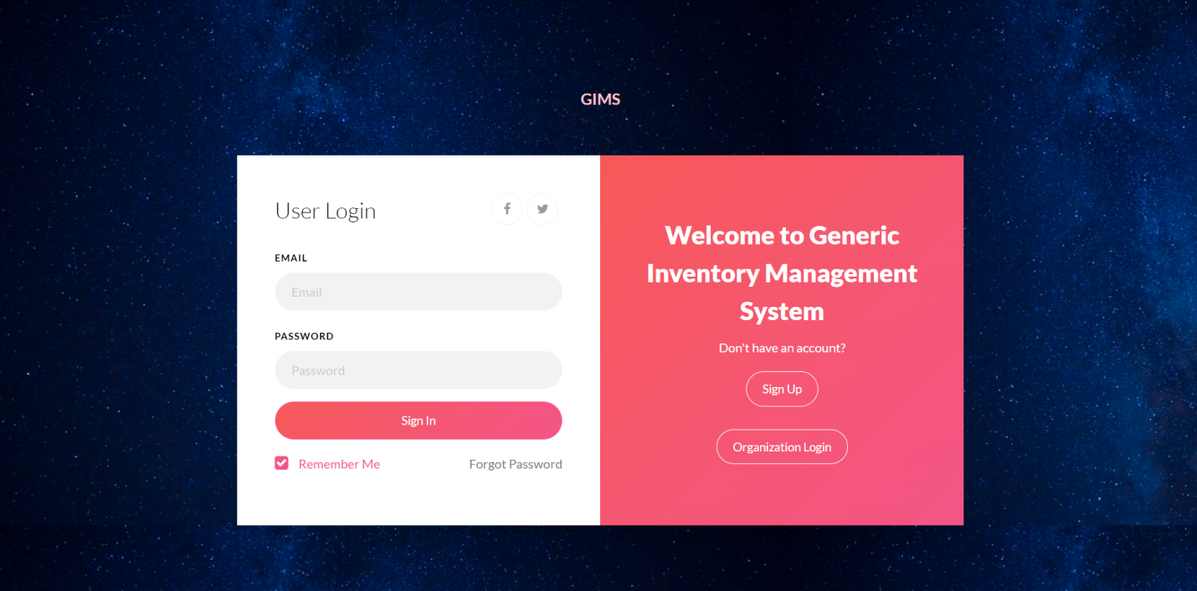

* Complete your registration process by providing the required data to create a **Super Admin Login.**

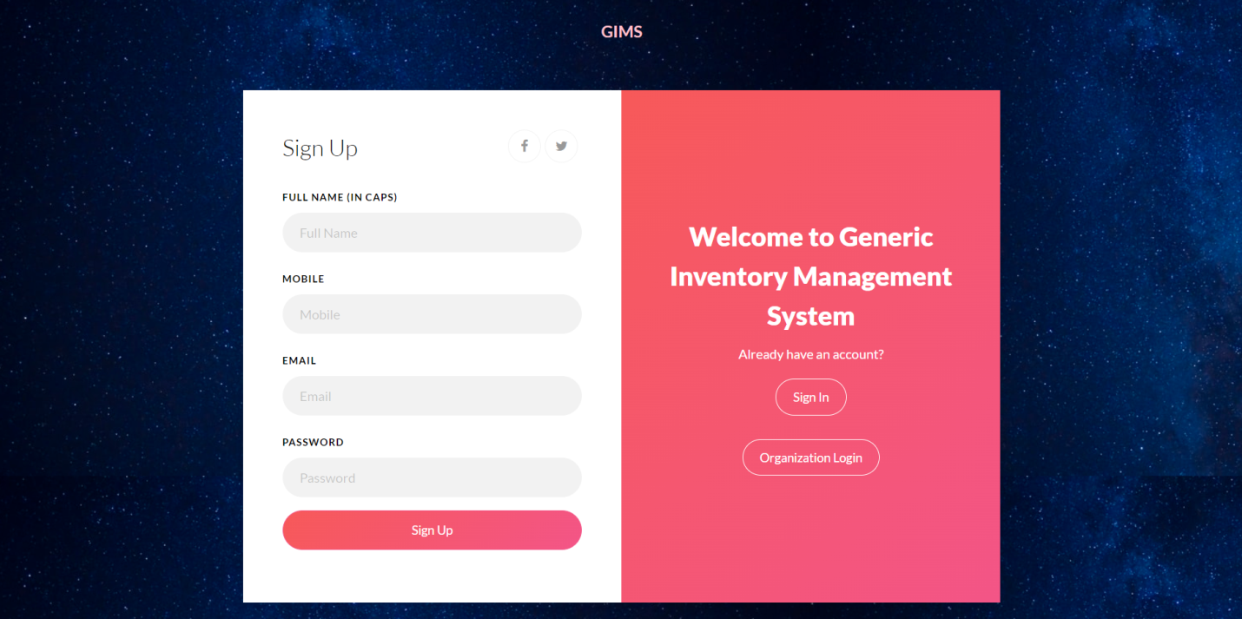

**LOGGING IN AS SUPER ADMIN:**

* Once all the data was entered in the “Sign Up” form and “Sign Up” Button was clicked, you will be automatically re-directed to the **“Login”** Screen. (Or, you can click on “**Sign In”** Button to navigate to the Login Screen. Please note that you will be automatically land on the Login Screen by default whenever you open Generic Inventory Management System)
* Login with your **Email & Password** (Please enter the email & password that you have used to sign up for Super Admin)

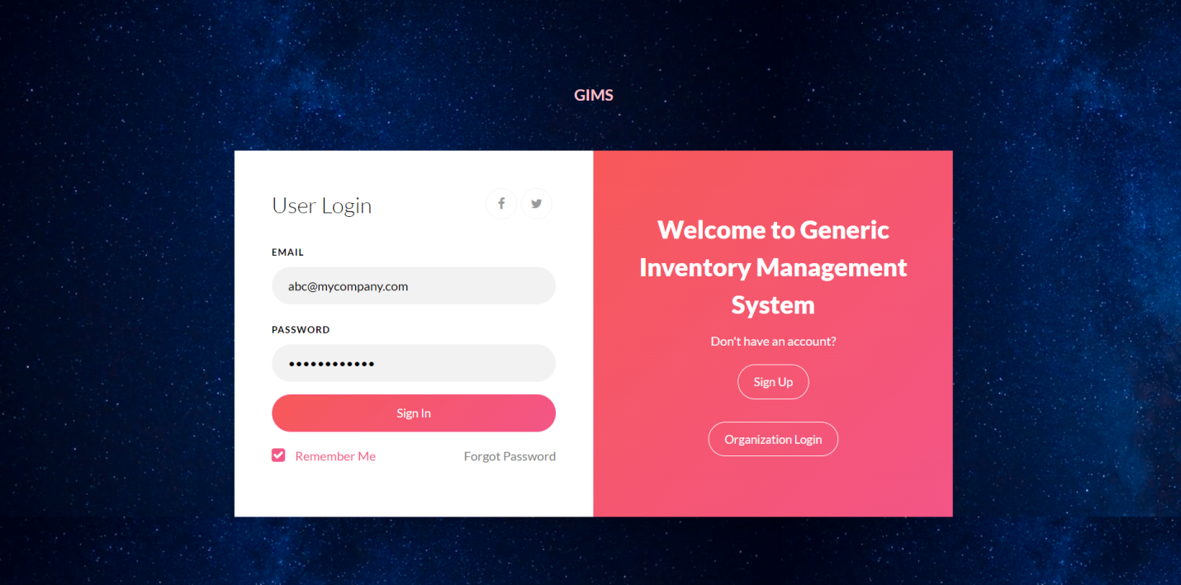

* Once you logged in, you will be landing on “**Add Company”** Screen. Provide your company & all required details in the form and click on “**Submit**”
* In the next tab, you can see **“Add users”** menu. Click on **“Add users”**  menu to add the users of your company
* In “**Add users”** screen, you can see only field called “**Company Name”.** Please select the company name on which the user belongs to
* In the last field, you can see **“Select user role”.** In that you will be provided with the below 2 options:
  + **Admin (Full access) 🡪** All access will be granted (including modifying the data)
  + **Viewer (Limited access) 🡪** Only can able to see the data (unable to modify/edit it)

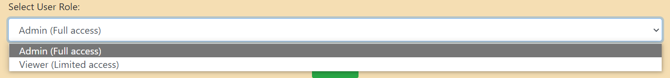

* So, select the **“User Role”** accordingly

**LOGGING IN AS ORGANIZATION:**

* Once user was added, Super Admin needs to share the user login credentials to the particular user, so that user can able to login as Organization
* Click on “**Organization Login”** to login as an Organization user

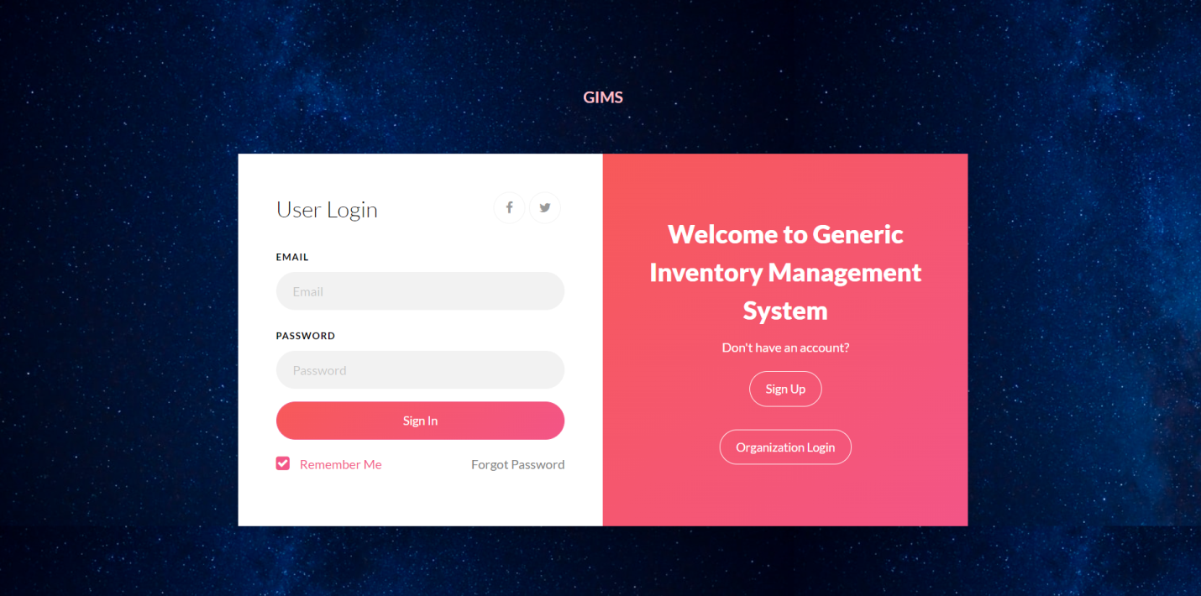

* Login with your Organization login credentials (provided by your Administrator)
* Once you login, you will be re-directed to **“Add Customer”** screen. In that screen, provide your customer details and click on **“Submit”**
* Please refer the below image for the list of menus



* Click **“Add Products”** to and provide all the required data to add the products
* Click “**Modify/Delete Products”** to modify or delete any products

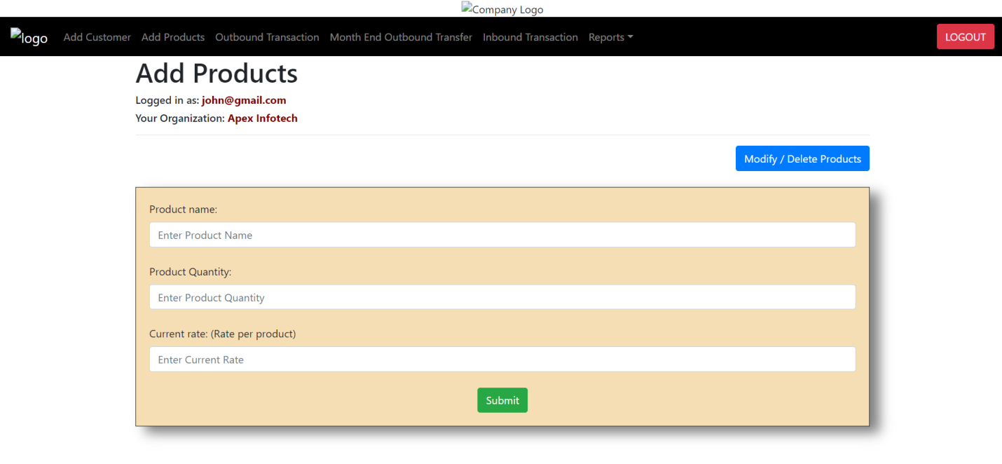

**OUTBOUND TRANSACTION:**

* Click on **“Outbound Transaction”** from the menu
* For performing outbound transaction, select the customer name in the drop down. (Make sure you have selected a customer name, it’s mandatory to select a customer name)

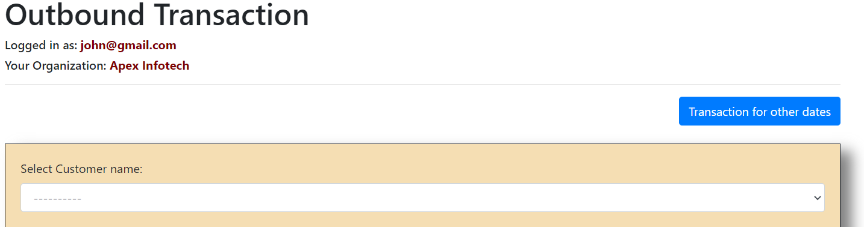

* Below the customer name, you can see the list of your products. Click on the Check Box beside the products. Once, check box was enabled, you can see “**Required Quantity”** field also enabled. (Please note that it is mandatory to enable the check box of the particular products to perform transaction)

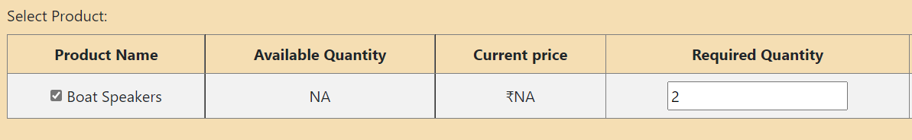

* Once check box was enabled, please enter the **“Required Quantity”**  to proceed with the transaction
* You can see the Price of the transaction on the screen
* Once all the details was provided, click on the **“Submit”** button in the bottom to proceed with the outbound transaction
* Once **“Submit”** button was clicked, you can see a confirmation screen of your selection. Please make sure you have given the correct data and click on **“Proceed**”
* To update the Outbound transaction for other dates, you can see a **“Transaction for other dates”** button on the Outbound Transaction screen. Click on that

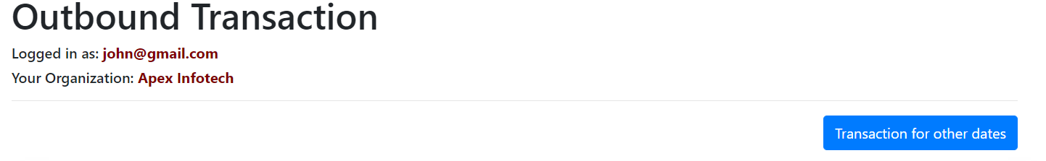

* In **“Transaction for other dates”** screen, you can give the date of transaction for Outbound Transactions

**MONTH END OUTBOUND TRANSFER:**

* To transfer the previous month’s data to the next month, click on **“Month End Outbound Transfer”** Menu

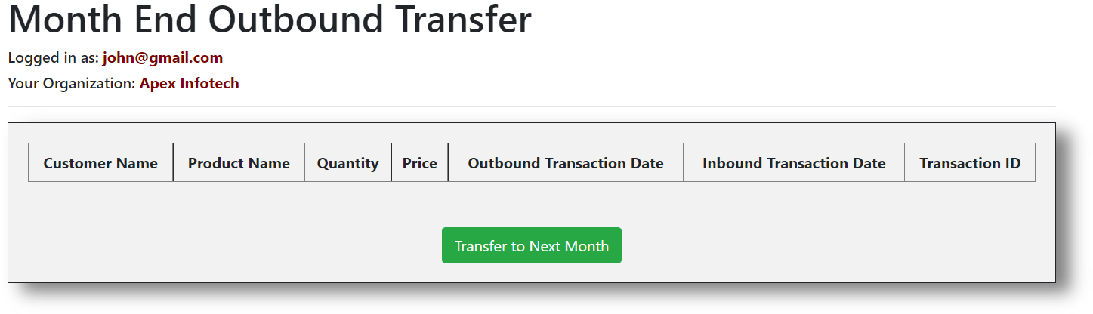

* Your transaction details will be listed there, click on **“Transfer to Next Month”** button in the bottom to do the transfer

**INBOUND TRANSACTION:**

* Click on **“Inbound Transaction”** Menu to perform Inbound Transactions

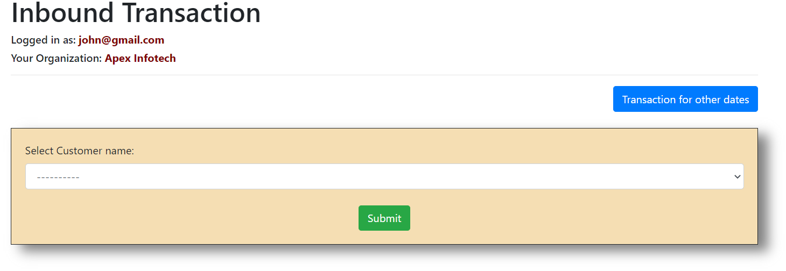

* Select the “**Customer Name”** to get the Outbound Transaction details of the particular customer
* From the list of transactions, to perform inbound transaction, enable the check box for the particular transaction to enter the quantity of inbound products
* Click on **“Submit”** once all the required data are entered
* To enter inbound transaction for other dates/previous dates, click on **“Transaction for other dates”** button in the Inbound transaction screen as shown in the above image
* In Inbound Transaction for other dates, please enter the date for the inbound transaction to perform Inbound Transaction for that date

**REPORTS:**

* To see all the reports (including inbound/outbound transaction reports, product reports, customer reports, billing and so on), click on “**Reports”** drop-down and select a report to view

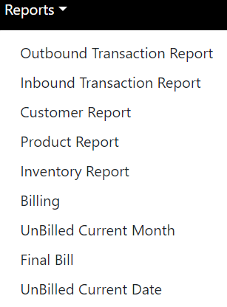

******************** ***Thank You*** ********************